DIGITAL TRAFFIC LIGHT SYSTEM

BASIC ELECTRONICS LAB

PROJECT REPORT BY:

Abrar Ul Abdin

**TABLE OF CONTENT**

|  |  |
| --- | --- |
| **CONTENT** | **PAGE #** |
| INTRODUCTION TO THE PROJECT | 2 |
| WORKING OF PROJECT | 2 |
| COMPLETE CIRCUIT DIAGRAM | 3 |
| APPLICATIONS and ADVANTAGES | 4 |
| MEMBERS | 5 |

**INTRODUCTION TO THE PROJECT**

This circuit is for digital traffic control using ic 555 timer and decoder

# Component requirement:

* IC 555 timer
* IC 4017 (DECODER)
* DIODE 1BH62
* RESISTER
* CAPACITOR
* INDICATOR
* DC POWER

# Component Description:

DC power ,resistors and capacitors have their conventional use.IC 555 timer generates electric pulse.IC 4017 is a decoder which receives impulse and gives it to output terminal. Indicators have their conventional use.

**WORKING OF OUR PROJECT**

When voltage is applied to the circuit and it reaches IC 555 timer it generates electric pulse .These pulses are then received by IC 4017(decoder).Decoder after receiving signal sends it to it corresponding terminal and a indicator is attached to all the terminals. Terminal 1,2,3,4 are connected to a single common point.

terminal 6,7,8,9 are connected to a single common point. While terminal is connected to single indicator.

# COMPLETE CIRCUIT DIAGRAM

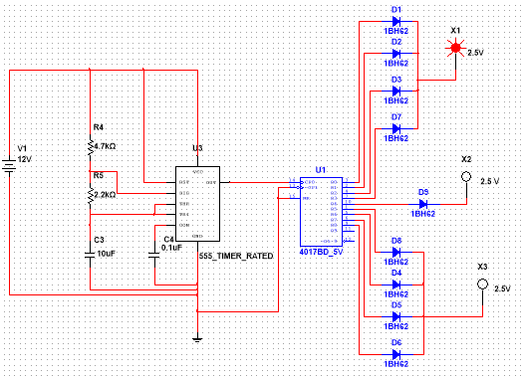

Application

• this circuit can be used in digital traffic control system

Advantages:

• By using digital traffic control system we do not to diploy traffic police man on roads.

# APPLICATION AND ADVANTAGES

**GROUP MEMBER NAMES:**

Abrar Ul Abdin: CS191007